

CCT College Dublin Continuous Assessment

Programme Title: | BSc Computing and IT
Delivery Mode: | FT
Cohort Details: | DataVisComms_BScCompIT_Sept23 FT Stage 4 Semester 1
Module Title(s): | Data Visualisation and Communication
Assignment Type: | Individual | Weighting(s): | 60%
Assignment Title: | CA2
Lecturer(s): | Taufique Ahmed
Issue Date: | 09-11-2026
Submission Deadline Date: | 04-12-2026, 23:59
Late Submission Penalty: | Late submissions will be accepted up to 5 calendar days after the deadline. All late submissions are subject to a penalty of 10% of the mark awarded.  Submissions received more than 5 calendar days after the deadline above will not be accepted and a mark of 0% will be awarded.
Method of Submission: | This assignment is submitted via Moodle.
Instructions for Submission: | Submit a Jupyter Notebook (.ipynb) to Moodle. Do NOT upload any data.  Record a 5-minute screen capture explaining your work. Save the video to your Google Drive, set the sharing permissions to “Anyone with the link,” and then upload the link to Moodle.  Add GitHub and recorded video link in the first cell of the Jupyter notebook.  Word document, which covers the use of AI.
Feedback Method: | Results posted in Moodle gradebook
GitHub classroom link | Create your own GitHub repository and provide the access to tahmed1986 GitHub account.
Feedback Date:

Assessment Outline

Background

The module Data Visualisation and Communication focuses on turning raw data into clear, useful insights through charts, dashboards and narrative. In this assessment, you will work with a real-world Online Retail dataset from a gift wholesaler, containing transactional data such as invoice numbers, product codes, descriptions, quantities, prices, timestamps, customer IDs and countries. The company has grown quickly but has not systematically analysed this data, so managers lack a visual understanding of which products drive revenue, which countries are most important, and how sales behave over time. A copy of the dataset (or a prepared version) will be available on the module’s Moodle page.

Assessment Details

As a data analyst for this retailer, your first task is to assess and clean the dataset. You should inspect the structure of the data, identify missing values, outliers, duplicates and clearly invalid records (for example, cancelled transactions or negative quantities), and note any limitations. You are expected to carry out appropriate data cleaning and preparation, including handling missing values, removing or correcting invalid entries, converting data types (such as dates) and creating at least one useful derived variable (for example, total order value). In Markdown cells, briefly explain and justify your cleaning decisions with reference to business logic and data quality. [0–20%]

After cleaning, you should perform exploratory data analysis (EDA) and produce a range of static visualisations to understand sales across products, customers and countries. This should include descriptive statistics and multiple chart types (for example line, bar, histogram, scatter) to explore patterns such as sales over time, top-selling products, distribution of order values or quantities, and differences between key countries or customer groups. For each important visual, provide a short Markdown interpretation of what it shows and justify why that chart type is appropriate for the question you are answering. [0–20%]

Building on your EDA, you must design and implement an interactive dashboard using an appropriate tool (for example, Python with ipywidgets and matplotlib/plotly, or another agreed tool). The dashboard should have a clear layout and include meaningful filters such as date range, country selection or minimum order value. It should combine several complementary visualisations that help a manager quickly understand revenue, product performance and regional patterns. In Markdown, briefly describe the intended audience, outline the structure of the dashboard, and justify your choice of filters and chart types in terms of usability and communication. [0–30%]

Throughout the notebook, you must demonstrate good written communication using Markdown cells. Introduce each major section (data quality, cleaning, EDA, dashboard), interpret key results in clear and concise language, and note any important limitations of your analysis. For each major method or visualisation, explain why you chose that approach and how it helps answer the business questions. Your writing should be professional, logically structured and understandable to a non-technical stakeholder. [0–20%]

In addition to the notebook, you must create a screen-recorded video (up to 5 minutes) in which you walk through your notebook and dashboard, explaining the main steps of your code at a high level, highlighting key visualisations and insights, and demonstrating how the interactive dashboard can be used. You are also required to manage your work using GitHub (minimum 10 commits), with a repository for this assessment and regular, meaningful commits with clear messages; include a link to your repository in your submission. Marks will be awarded for clear oral explanation in the video and for evidence of good version-control practice. [0–10% total for video + GitHub]

Important Note – Q&A Sessions (Mandatory Attendance)

An in-class QA session for this assessment will be held on 7th December. Attendance is compulsory for all students. During the session, a few students will be randomly selected to demonstrate and explain their work, including data cleaning, visualisations, dashboard design, and interpretations. Students must be able to clearly explain and justify their approach.
Failure to attend the QA session will result in a grade of zero for this assessment.

Assessment Requirements
All assessment submissions must meet the following minimum requirements:
- Be submitted in the format outlined in the assignment summary table.
- Be submitted by the deadline date specified or be subject to late submission penalties.
- Be submitted via Moodle upload.
- Use Harvard Referencing when citing third party material.
- Be the student’s own work.
- Include the CCT assessment cover page.

Learning Outcomes:
This assessment addresses the following module learning outcomes for this module:

MLO 3 - Select appropriate data visualisation techniques for a given use case and data
Characteristics.
MLO 4 - Propose, design, develop, and implement data visualisation solutions. (Linked to PLO 4 (Stage 4 SLO 4))
MLO 5 - Display effective presentation skills to communicate with peers, team members and project stakeholders. (Linked to PLO 3, PLO 6 (Stage 4 SLO 3, SLO 6))

Use of Artificial Intelligence
This assessment applies the AI Fluency Framework — four interconnected competencies for effective, efficient, ethical and safe AI use. Your engagement with AI will be reviewed across all four dimensions:
Delegation  Setting goals and deciding whether, when and how to engage with AI. | Description  Effectively describing goals to prompt useful AI behaviours and outputs.
Discernment  Accurately assessing the usefulness of AI outputs and behaviours. | Diligence  Taking responsibility for what we do with AI and how we do it.

AI tools may be used in this assessment. Your use of AI will be assessed across the four ‘D’ competencies of the AI Fluency Framework.

AI Declaration using the AI Fluency Framework
For use in assessment briefs and student submissions. Lecturers complete the Lecturer Expectations column per assessment; students complete the Student Response column.
AI competence | Reflective prompts (to students) | Lecturer expectations | Student response
Delegation  Deciding whether & when to use AI | Identify the specific tasks in this assessment where you chose to use AI, and explain your reasoning. Where did AI add value? Where did you decide not to use it, and why? | You may use AI to support your learning and development of the application. Clearly identify where you used AI and where you completed the work independently. | Briefly state which parts of your application assessment you used AI for and why.
Description  How you prompted the AI | Include the exact prompts you used in your appendix (recorded on the AI Tools declaration). Reflect on how you communicated your goals to the AI — did you need to iterate or refine your prompts to get useful output? | You must provide the exact prompts and relevant AI outputs used during the development of your application. | Include the exact AI prompts and outputs in your submitted AI-use Word document.
Discernment  Evaluating what the AI produced | In your reflection, critically evaluate the AI output: what did you accept, modify, or reject — and why? Assess accuracy, relevance, and quality. You are responsible for verifying all AI-generated content before submitting. | You are responsible for checking, testing and understanding any AI-generated code or suggestions before using them in your work. | Briefly explain how you verified the AI output and what you accepted, modified or rejected.
Diligence  Responsibility for your AI use | Declare all AI tools used and cite them here. Briefly outline how you considered data protection, copyright, and ethical responsibilities when choosing what to input into any AI system. Unauthorised use is subject to CCT disciplinary procedures. | Declare all AI tools used. Do not enter personal, confidential or sensitive information into AI tools. Any external sources used should be appropriately referenced. | List the AI tools used and briefly explain how you used them responsibly.

Adapted from the AI Fluency Framework (Dakan, Feller, Anthropic, 2025)

Grading Criteria
This grading rubric sets out the marking criteria for your assignment.

IMPORTANT NOTE: You *must* include a completed Appendix showing your AI use. If this is not included, you will not receive any marks!
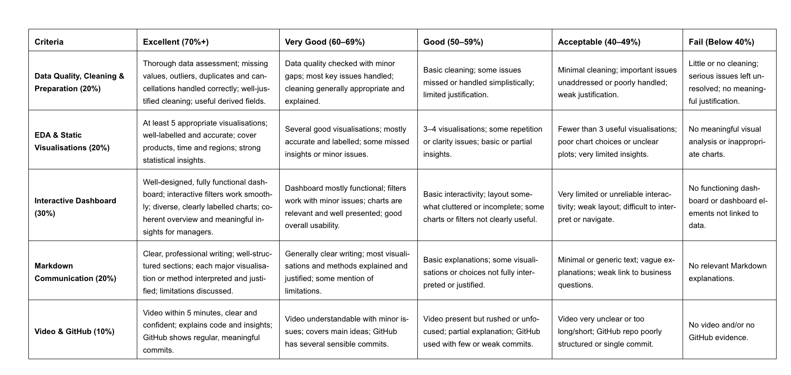

The Irish Grading System

The grading system in CCT is the QQI percentage grading system and is in common use in higher education institutions in Ireland. The pass mark and thresholds for different grade bands may be different from what you have experienced in the higher education system in other countries. CCT grades must be considered in the context of the grading system in Irish higher education and not assumed to represent the same standard the percentage grade reflects when awarded in an international context.

Please review the CCT Grade Descriptor available on the module Moodle page for a detailed description of the standard of work required for each grade band, and review the marking criteria outlined in this assignment brief for a breakdown of the marking criteria for this specific assignment.

Additional Information
- Lecturers are not required to review draft assessment submissions. This may be offered at the lecturer’s discretion.
- In accordance with CCT policy, feedback to learners may be provided in written, audio or video format and can be provided as individual learner feedback, small group feedback or whole class feedback.
- Results and feedback will only be issued when assessments have been marked and moderated / reviewed by a second examiner.
- Additional feedback may be provided as individual, small group or whole class feedback. Lecturers are not obliged to respond to email requests for additional feedback where this is not the specified process or to respond to further requests for feedback following the additional feedback.
- Following receipt of feedback, where a student believes there has been an error in the marks or feedback received, they should avail of the recheck and review process and should not attempt to get a revised mark / feedback by directly approaching the lecturer. Lecturers are not authorised to amend published marks outside of the recheck and review process or the Board of Examiners process.
- Students are advised that disagreement with an academic judgement is not grounds for review.
- For additional support with academic writing and referencing students are advised to contact the CCT Library Service.
- For additional support with subject matter content students are advised to contact the CCT Student Mentoring Academy
- For additional support with IT subject content, students are advised to access the CCT Support Hub.

